Exercise 4: Arrange-Act-Assert (AAA) Pattern, Test Fixtures, Setup and Teardown Methods in Junit
Scenario: You need to organize your tests using the Arrange-Act-Assert (AAA) pattern and use setup and teardown methods
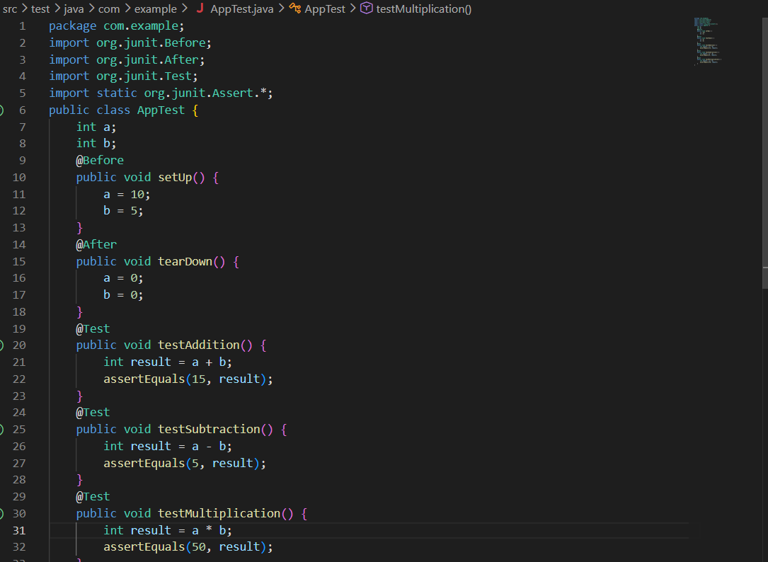
Output
